Fearless Leadership® - Accessing untapped potential
Courageous conversations to build trust and move us forward.
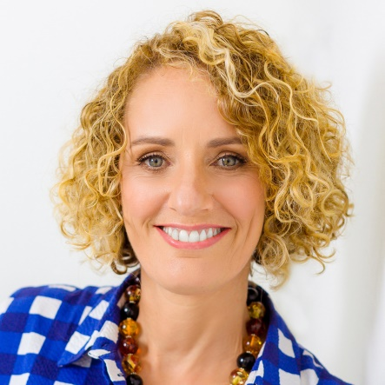
Corrinne is Australia’s leading thinker in Fearless Leadership®, and a Certified Speaking Professional. Her unique experience spans corporate leadership roles, living in a jungle war-zone, and 20 years of training leaders.
Entertaining, provocative and inspiring. She combines brain science insights and impactful stories, making her a captivating presence on any stage, real or virtual. Author of ‘Leaders Who Ask: Building Fearless Cultures by telling less and asking more’ and ‘Developing Direct Reports: Taking the Guesswork Out of Leading Leaders’.

